**DAILY ONLINE ACTIVITIES SUMMARY**

|  |  |  |  |  |  |  |  |  |
| --- | --- | --- | --- | --- | --- | --- | --- | --- |
| **Date:** | **25-6-2020** | | | | | **Name:** | **Poojashree T** | |
| **Sem & Sec** | **8th sem B sec** | | | | | **USN:** | **4al16cs064** | |
| **Online Test Summary** | | | | | | | | |
| **Subject** | | **SMS** | | | | | | |
| **Max. Marks** | | **60** | | **Score** | | | **Not received mail** | |
| **Certification Course Summary** | | | | | | | | |
| **Course** | **Introduction to R language tutorial** | | | | | | | |
| **Certificate Provider** | | | **Great learning academy** | | **Duration** | | | **3.0hr** |
| **Coding Challenges** | | | | | | | | |
| **Problem Statement:** **1**. **to read the number and compute the series.**  **2. to count the number in th series.**  **3. to check whether number is palindrome or not.**  **4. to find the number between 0 and 50 which are not divisible by 2 and 3.**  **5.micro and array update**  Top of Form | | | | | | | | |
| **Status:completed** | | | | | | | | |
| **Uploaded the report in Github** | | | | | **yes** | | | |
| **If yes Repository name** | | | | | **Poojatgowda** | | | |
| **Uploaded the report in slack** | | | | | **yes** | | | |

**Online test**

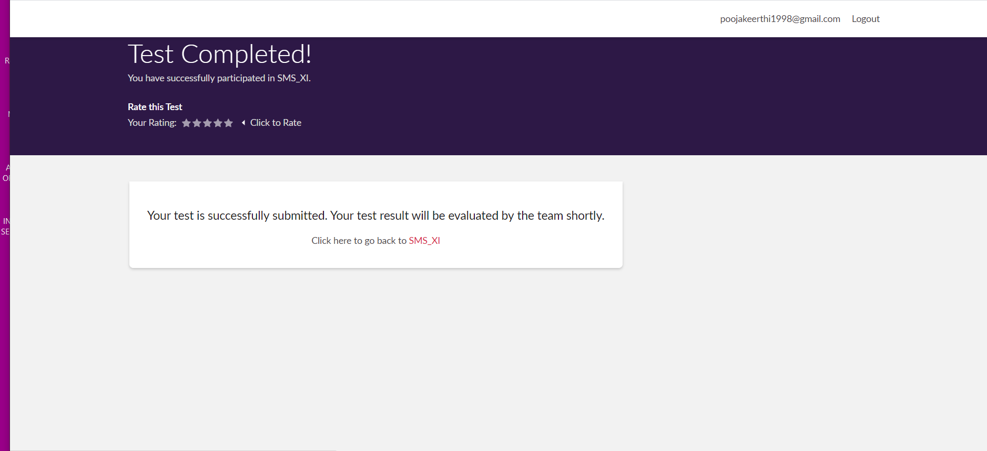

**Certification course**

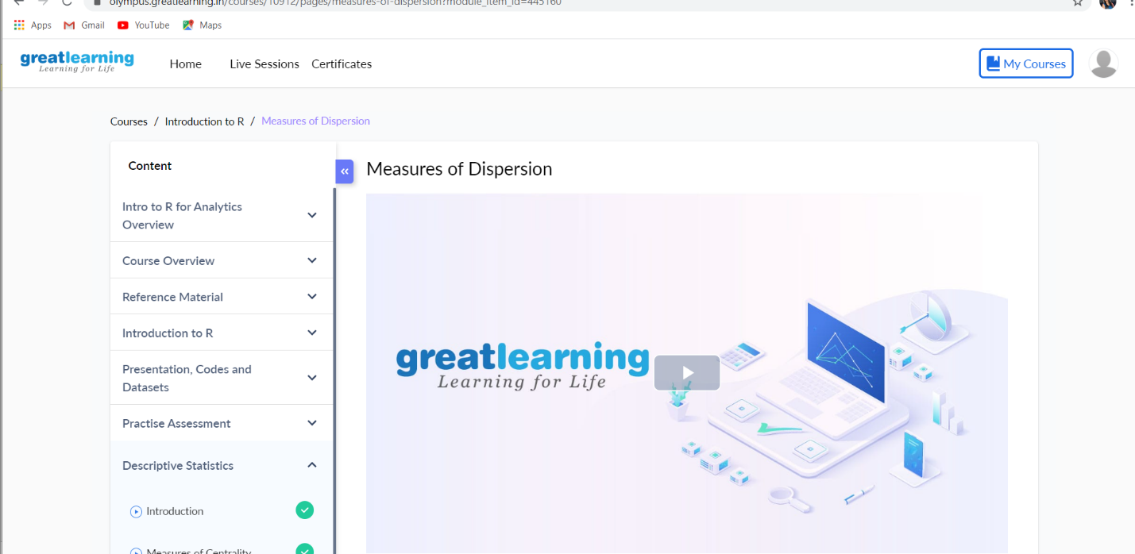

Coding

**Reverse a given number using Recursion:**

In this program, we are calling a user defined function “reverse_function”, the function is calling itself recursively.

#include<stdio.h>

int main(){

int num,reverse_number;

//User would input the number

printf("\nEnter any number:");

scanf("%d",&num);

//Calling user defined function to perform reverse

reverse_number=reverse_function(num);

printf("\nAfter reverse the no is :%d",reverse_number);

return 0;

}

int sum=0,rem;

reverse_function(int num){

if(num){

rem=num%10;

sum=sum*10+rem;

reverse_function(num/10);

}

else

return sum;

return sum;

}

Output:

Enter any number: 23456

After reverse the no is :65432